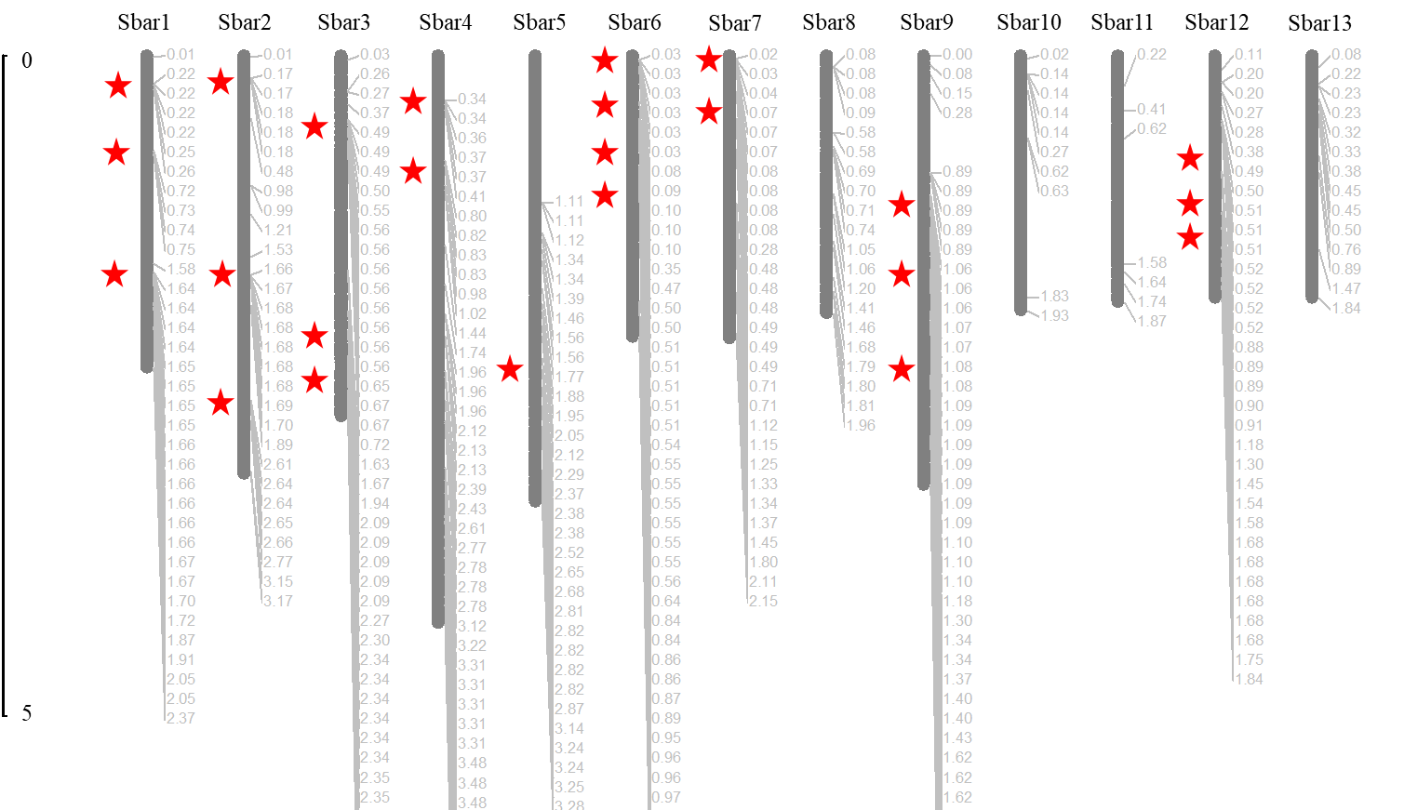

Supplementary Figure S17. The physical clusters of CYP450s (5 gene clusters per 500 kb) in *S. barbata*.